Wireframe Details

**Template** – We looked at other clothing websites and used them as reference for ours

**Colour** – Needs a neutral focus as both men and women will use the site so we chose soft brown colours

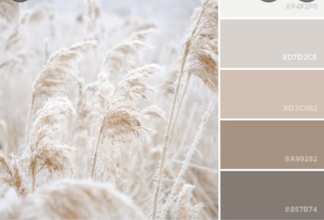

**Views:**

Mobile viewDesktop view

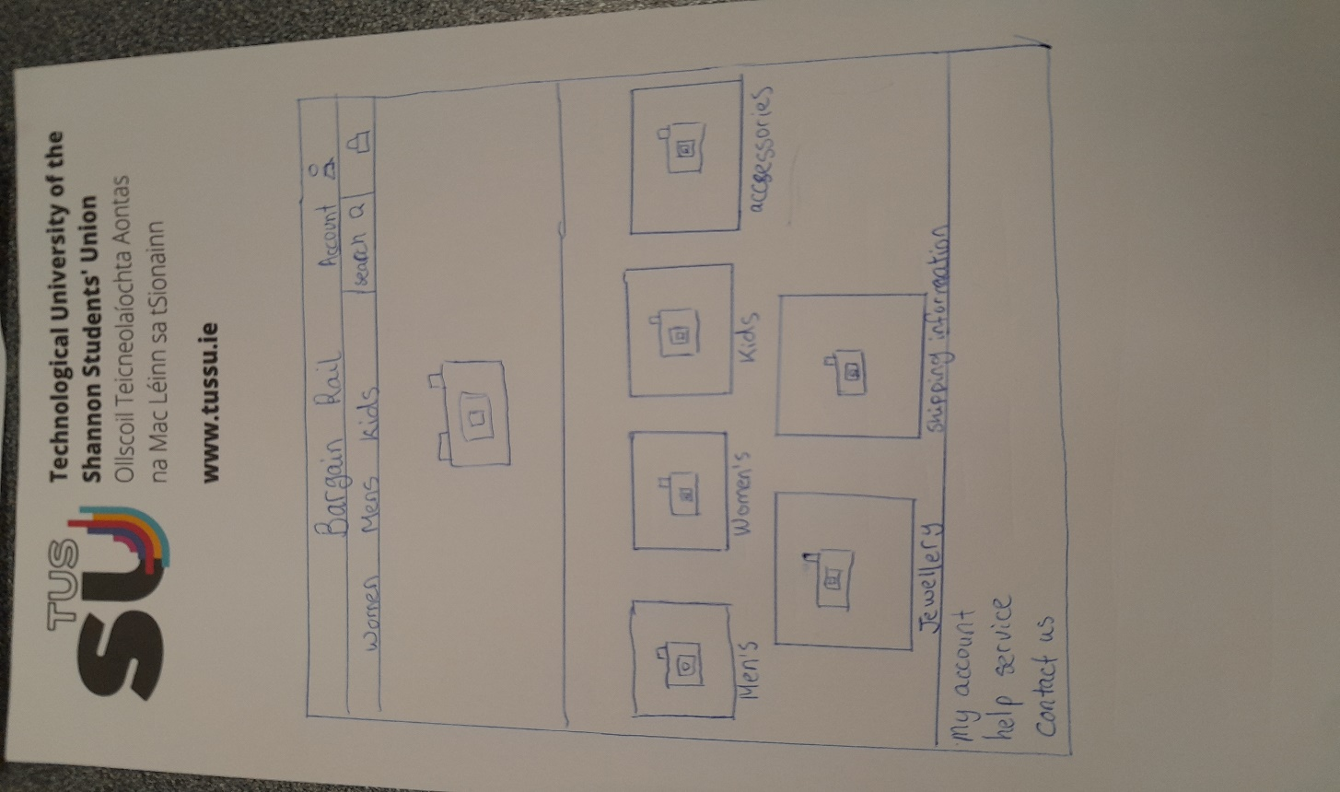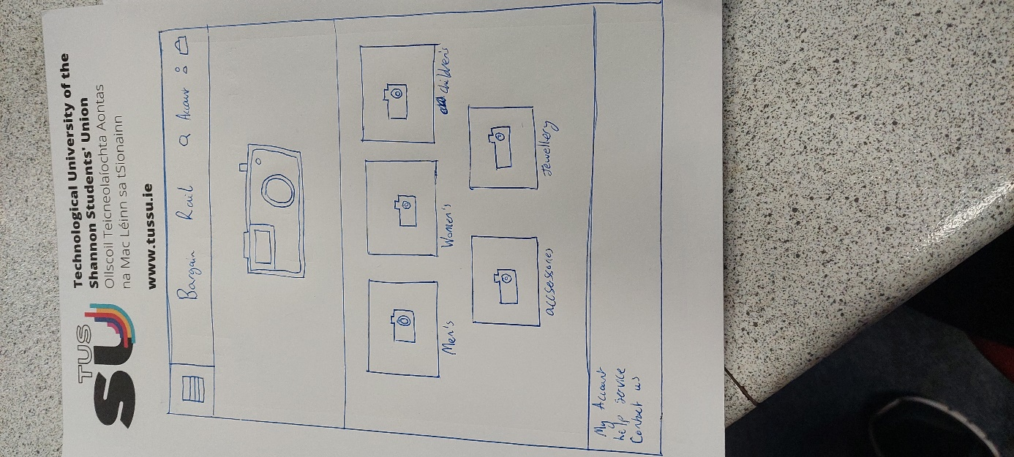

**Personas:**

